 BELONGING TO AN 

“UNWANTED CLUB”

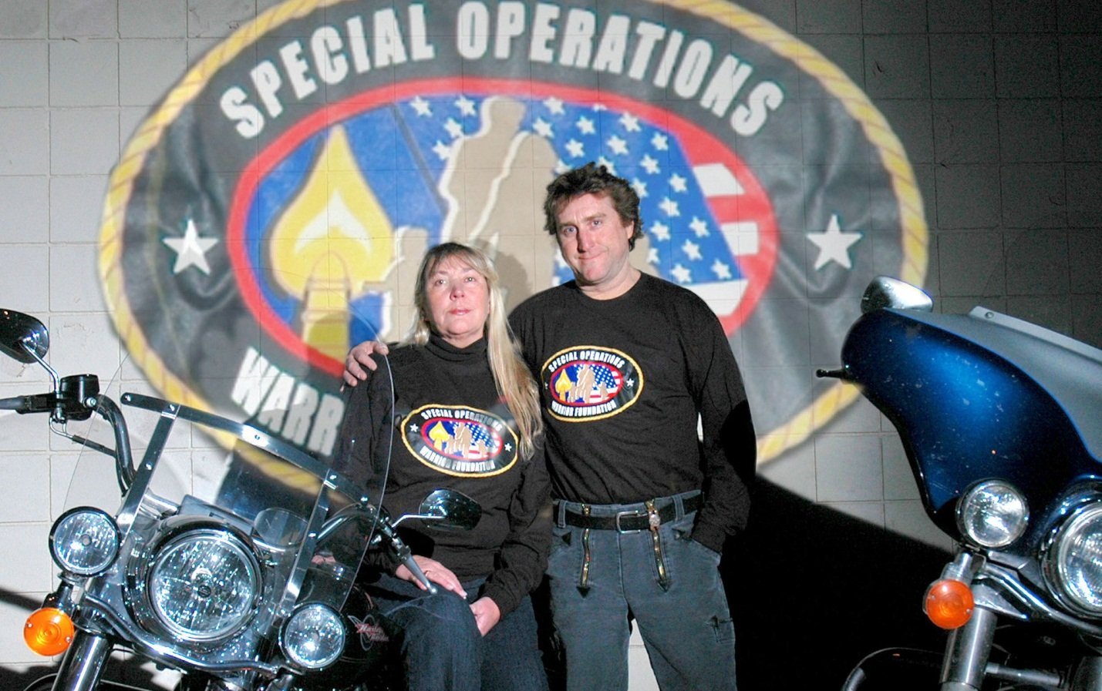
America's Gold Star families—those who have lost someone in a war—stand distinctly apart in society in terms of sacrifice. For some families of the 6,500 Americans killed in Iraq and Afghanistan, life has become bearable by adopting inspirational ways to cope. One family provides a poignant reminder that the war continues long after the shooting stops. BY DEB TAINSH
On February 12, 2004, 6 a.m., my husband, retired Marine Sgt. Maj. David Tainsh, and I received the knock that started us on a journey on how to cope and live with the death of a son at war.
Our son, Patrick, a cavalry scout sergeant with Eagle Troop, 2nd Squadron, 2nd Armored Cavalry Regiment, had been killed in Baghdad, Iraq. Mortally wounded in the throat, he died in his commanding officer's arms, but only after expending all of his ammo. Patrick was posthumously awarded the Silver Star.
We received a flag with a red border, white center and gold star in the middle. Accompanying the banner, we received the following letter that provided little consolation:
Please accept this gold star banner as a symbol of your son's sacrifice and your loss. The tradition of a family who had a loved one die in combat by displaying a gold star banner dates back to WWI. Your son has now joined the ranks of other heroes who have made the ultimate sacrifice to protect our freedom. Sergeant Patrick Tainsh now lives in our hearts and memories. His sacrifice will not be forgotten.
That first year after Patrick's death, we barely coped. All those who gave a smile and said, "Call us if you need us," always seemed to have an excuse if I did call them.
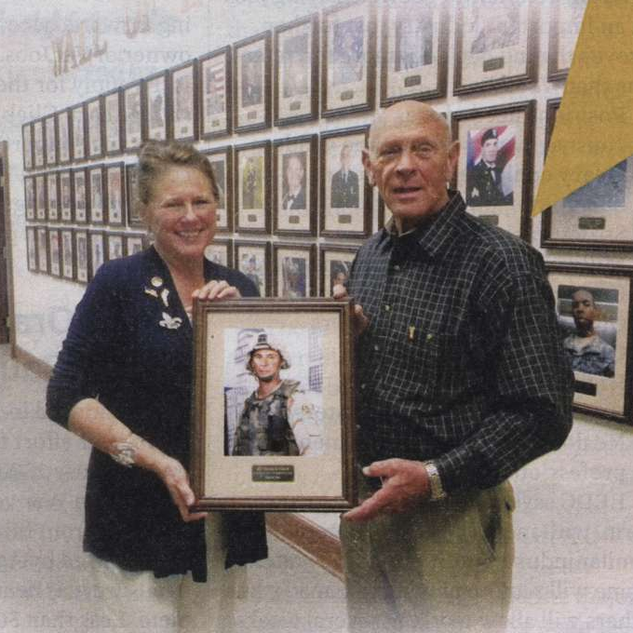
Deb and David Tainsh hold a portrait of their son, Sgt. Patrick Tainsh, just before it was mounted on the Wall of Heroes at the Survivor Outreach Services Office at Ft. Benning, Ga., in March. To further honor their fallen son, E/5-15 Cav Troop Operations Facility and Barracks was named Tainsh Barracks.
The world moved on while we stood still. We still stand still while others have weddings, grandchildren and all the icing on the cake of life.
After a year, David and I found out about the Tragedy Assistance Program for Survivors in Washington, D.C. There, we found peace by connecting to others who had suffered the same type of loss. Together we began holding one another up, validating our emotions and how to cope in our new norm, but allowing us to survive. We trained to become peer mentors to other Gold Star (GS) families. Whether by phone, e-mail or personal visits, we met with others in need of a common shoulder to confirm the roller coaster of emotions and broken hearts.
Talking with others who have experienced the same loss has been helpful. But I also cope by writing to remember everything about Patrick and how our family adjusts to his physical absence. Over a period of five years, three books were published: Heart of a Hawk (2006), Surviving the Folded Flag (2010) and Dear Warrior & Hero (self-published), which have been tools used by other families.
My husband has his own ways of coping. As a Marine, he has a special perspective. He served in Vietnam with the 9th Marine Regt. and 11th Marine Engineers around Dong Ha during 1967-68. In the 1991 Persian Gulf War, he was with Marine Air Traffic Control Squadron 38. He is a member of VFW Post 10555 in Panama City Beach, Fla.
Dave says: "I cope best by knowing what an outstanding armored cavalry scout that Patrick became, and the pride and selflessness my son carried in service to his country and for others. And by receiving letters from his comrades regarding Patrick's great leadership."
During that first year, in memory of Patrick, we started the Sgt. Patrick Tainsh Books for Children, which provided free books to pre-kindergarten children in the lower income area of Columbus, Ga., to help them prepare for school.
While nothing can fill the void left by the loss of our son, we find comfort knowing that he made a difference.

MEMBERSHIP NOT WANTED
If ever there was a group to which one would not wish to aspire, it is the Gold Star fraternity of families.
"This is not a club any of us wanted to belong to," says Georgia GS mom Jan Johnson, "but since we are, we must move forward the best way possible." Jan's son Army Spc. Justin Johnson died in Iraq in April 2004.
"I have coped by being available for those who follow in our footprints, footprints we all wish no one ever had to follow again," Jan says. "I tell them they are not alone on this grief journey, we have each other when no one else understands the intensity of our loss. I believe this gives them a little strength, something we all know is needed to make it through the darkest days."
A motto GS families live by is: "It's not time that heals, it’s what we do with time."
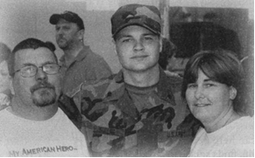
Brian Shilling of Tennessee, father of Spc. Bradley Shilling, KIA on Nov. 18, 2006, in Iraq, says, "I cope by continuing to do things Bradley and I did together like fishing, hunting, and enjoying motor sports. Although he isn't with me in the flesh, I know he's with me in the spirit." Brian became the Tennessee state captain for Gold Star Dads of America, founded by GS dad Michael Klasno of California.
Brian and Alison Shilling pose with their son Spc. Bradley Shilling, who was killed in action in Iraq in 2006. Brian says he continues to do the things that he and his son did together as a means of coping with Bradley's death.
For others, finding a quiet moment each day can help heal. Patty Smith of Tahoe, Calif., finds solace in words. Her son, Sgt. Timothy Smith, died in Iraq on April 7, 2008. "I write," Patty says. "I am on my 17th journal. I sit on the deck of my home every night and when it gets dark, I see Timmy's star appear as if he were waiting for me. This is our special time together." Patty also spends time with Timothy's brother and sister, wears his dog tags, and keeps in touch with his Army family.
Different families keep in touch with their lost loved ones in various ways, Ashlee Cote was married 18 months when her 20-year-old husband, Army Spc. Mike Cote, died in Iraq on Sept. 19, 2009.
"Mike had deployed before our daughter, Brooke, was born," says Ashlee. "He saw her once when she was eight weeks old."
Now, Brooke is three and, according to Ashlee, looks and sounds like her daddy. "Remembering the good times we had together and sharing those times with our daughter has been the best way for us to cope," Ashlee says. "We are very proud of our hero, and very happy that he fulfilled his dream of flying on a Blackhawk helicopter."

CREATING LEGACIES
Legacies have been created by GS families such as Stacey and John Holley of San Diego, Calif. Their only child, Army medic Spc. Matthew Holley, died on Nov. 15, 2005, in Iraq. "It hasn't been easy picking up the shattered pieces," Stacey says. "However, with our faith and help from others, John and I are making every effort to refocus."
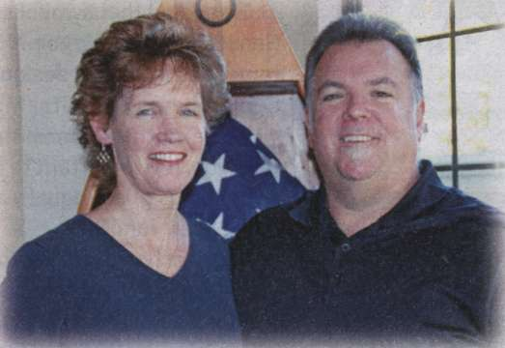
Stacey and John Holley were instrumental in passing legislation requiring that fallen warriors be returned home with dignity on contracted private jets.
Through their grief, the Holley's worked to keep our fallen warriors from returning home on commercial aircraft where they were met by family in commercial baggage areas.
"In October 2006, President Bush signed legislation, known as The Holley Provision, which now requires all of America's fallen warriors to be returned home to their loved ones with dignity, honor, and respect on contracted private aircraft," says John Holley. The Holley's also released a book, Medals, Flags, and Memories, which shares their journey after Matthew's death.
GS mom Kelly Kowall created FAVE Boating Expeditions in honor of her son, Army Spc. Corey Kowall. Serving with the 82nd Airborne Division, Corey died Sept. 20, 2009, in a vehicle rollover in Afghanistan's Zabul province.

FAVE provides a variety of boating trips for soldiers, veterans and families who have endured the death of a warrior.
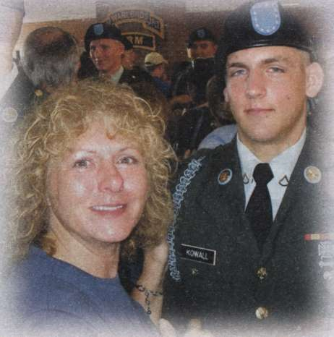
Kelly Kowall describes the day her son Spc. Corey Kowall finished basic training as one of her proudest. He died in Afghanistan on Sept. 20,2009
"To honor my son," Kelly said, "I was compelled to find a way to assist those who, like myself, were hindered mentally and emotionally due to some of the complex issues that arise when the one who dies has served in the military."
She recently purchased property in Ruskin, Fla., located directly on the Little Manatee River, to provide a peer mentoring program for military personnel and veterans. "After all, they are my son's brothers, so that makes them family to me," she says.
In June 2007, lawmakers in Connecticut authorized the distribution of Connecticut Gold Star license plates, thanks to Joseph's efforts. He said the plates serve as reminders of the ultimate sacrifice that so many Americans have made. A spouse, parent, grandparent, sibling or child of a veteran killed in action in any U.S. war can apply for a plate.
"I can't bring my son back, but I didn't want him to be another statistic that was forgotten," Joseph said. "This is a way to honor and remember Joe."
As for Dave and I, we created the non-profit Bereaved Military Families of America. During the first weekend of December, we host a retreat on Panama City Beach to help families ease the pain of getting through the holidays.
We also cope through our Hearts for Military Heroes support services for Bay County, Fla., veterans. We link vets to vets and provide emergency payment for utilities. Efforts by Hearts for Military Heroes has produced a wheelchair accessible van to transport veterans from the Naval Support Activity Center VA Clinic to Pensacola, Fla. Transport began on June 18, 2012.
GS families strive to cope in healthy ways, but they should not be alone. Few Americans know that the last Sunday of September is called Gold Star Mother's and Families Day—it helps relieve the grief.
I once heard a saying: "When one loses a partner, he or she is a widow. When children lose parents, they are orphans. But there is no word for the parents who lose children." It is absolutely without description.
In our case, our son also is remembered by Tainsh Barracks at Fort Benning, Ga. In that respect, we are among the fortunate families.
DEB TAINSH is located in Panama City, Fla., and is active in Gold Star issues.
Contacting Support Groups; Bereaved Military Families of America and Hearts for Military Heroes Veteran Support Program
Contact Deb or Dave Tainsh directly at (850)249-8975 or (850) 454-7760. E-mail deborahtainsh@msn.com or visit www.bereavedmilitaryfamiliesofamerica.org

Gold Star Mother's Day: Sept. 30, 2012

SPECIALLY RECOGNIZING THE FAMILIES, especially mothers, of Americans killed in war dates officially back to World War I. When a family had a member killed in France or elsewhere in 1917-18, a gold star replaced the blue star on a service flag flown in the front window of a home.
Extending that symbolism, Congress—through Senate Joint Resolution 115—on June 23, 1936 (amended in 1985), designated the last Sunday in September as Gold Star Mother's Day.
While mothers remain the focus of this noble tradition, it is important to bear in mind that fathers and siblings grieve equally and constitute the larger "Gold Star" family.
A further honor was bestowed two years after WWII, when a set of commemorative postage stamps was issued recognizing these exceptional mothers. A Gold Star Lapel Pin also distinguishes mothers and fathers who have lost a son or daughter while serving in wartime (a purple background signifies a battlefield death). Moreover, specialty license plates are available to Gold Star families in many states.
Sadly, few Americans today recognize these symbols of sacrifice. Still fewer are even aware that a special day of recognition exists and that it has bestowed honor for more than 75 years.
Letters for Logan
Letters for Logan is a collection of heart-felt letters written to a young boy after the tragic death of his father. Through the letters you learn about Logan's father, Air Force Capt. Derek Argel, who lost his life at age 28 on Memorial Day in 2005 while deployed to Iraq as an Air Force Combat Controller.
Within days of his death, the first letter to Logan arrived. Then the next one followed. The letters told of the sorrow of losing a friend and colleague, but also related stories of his time with fellow combat controllers, or of his time at the Air Force Academy, Each letter weaves an enduring portrait for a little boy, now 7, of a father who was taken too soon.
Compiled and written by Deb Argel-Bastian, the mother of Capt. Derek Argel, and grandmother to Logan, this heart-wrenching book, takes you through an extraordinary journey of her son's life.
"So many people have lost loved ones and the ripples extend so far beyond family," she said. "All these people we've lost, they're remembered as casualties. They all had a life. They all deserve to have their stories be told
Brandon Lingle, who counted Capt. Argel among his best friends while growing up in Lompoc, Calif, was compelled to write a letter for Logan.
"Just like the book's other contributors, I wanted to do what I could to help ensure Derek's life beyond his military service wouldn't fade away," explained Maj. Brandon Lingle, a public affairs officer for Air Combat Command, who is deployed in Afghanistan. "He was an extraordinary man with an amazing story.
I hope my words help Logan gain a sense of who his father was outside of the Air Force and war."
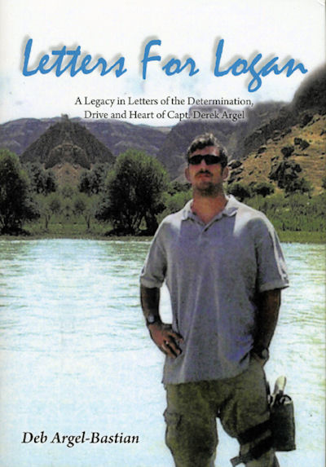
Proceeds from this book will go to the Special Operations Warrior Foundation.
"Letters for Logan is an amazing way to make sure everyone knows who Logan's father was and that he will never be forgotten," said John T. Carney, Jr., SOWF President.
The Special Operations Warrior Foundation has more than 900 surviving children of fallen special operators in its program, including some 140 students who are enrolled in colleges and universities across the country.
"I think about all the kids who will say “I don't know my dad,” explained Deb Argel-Bastian. "Logan, thanks to these people, will know his dad. Through them, Logan will know his dad."
"Letters for Logan" can be purchased online at Amazon.com, Ctrl/click here.

Fred Bozak; Special Forces Friend of CCT; Anyone interested in attending my dad’s service in Arlington, the date will be Sept 25th at 0845. Any questions you can email me at rbozek3@msn.com, thanks……. Bob Bozek
Ty Barnes; Active duty troop perishes in motorcycle accident
J. C. Bradshaw; has left this world
Jim Stanford; my friend, gone

WHAT TO DO? I HEAR AND I UNDERSTAND!
All those who gave a smile and said, "Call us if you need us," always seemed to have an excuse if I did call them.
The world moved on while we stood still. We still stand still while others have weddings, grandchildren and all the icing on the cake of life.
"I tell them they are not alone on this grief journey, we have each other when no one else understands the intensity of our loss. I believe this gives them a little strength, something we all know is needed to make it through the darkest days."
A motto GS families live by is: "It's not time that heals, it’s what we do with time."
Through their grief, the Holley's worked to keep our fallen warriors from returning home on commercial aircraft where they were met by family in commercial baggage areas.
"To honor my son," Kelly said, "I was compelled to find a way to assist those who, like myself, were hindered mentally and emotionally due to some of the complex issues that arise when the one who dies has served in the military."
GS families strive to cope in healthy ways, but they should not be alone. Few Americans know that the last Sunday of September is called Gold Star Mother's and Families Day—it helps relieve the grief.
CCT Gold Star Family Reunion, A Toast To Our Fallen
Bringing these families together is what I understand.
All those who gave a smile and said, "Call us if you need us," always seemed to have an excuse if I did call them.
I’m calling YOU………… Mac

