Memorial Day Weekend Golf, Columbia, MO.
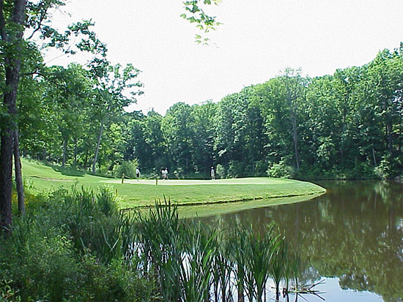

Saturday, May 25th, 0900: Eagle Knoll Golf Course; 5757 E Eagle Knoll Dr. Hartsburg, MO 65039-9664
Toll Free: (800) 909-0564
(573) 761-5932
http://www.eagleknoll.com
4person Scramble (Best Ball); 1 score per team and must use 1 drive from each team member, not counting par 3’s. Standard scoring, no handicaps, low score wins.
Prizes awarded to 1st and 2nd place teams, longest drive, and closest to the pin on par 3.
Contact Tom Butcher, my neighbor and Golf Pro to sign-up and/or questions. tombutcher44@yahoo.com or (602) 549-8024. Please sign up by 5/10 so he can reserve your spot.
4 man teams of your choice and drawing to fill in or make teams……………. Good Luck, and have FUN!

Memorial Day Weekend Golf, Columbia, MO.
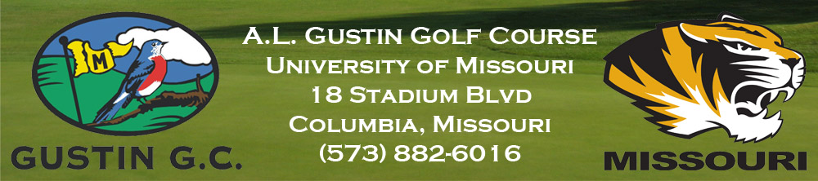

Sunday, May 26th, 0900; A.L. Gustin Golf Course; http://www.gustingolfcourse.com/
4 person Scramble (Best Ball) playing Modified Stratford Rules; Eagle 5 pts., Birdy 2 pts., Par 1 pt., Bogey 0 pt’s., Dbl Bogey -2 pts………….. High Score Wins. 1 score per team and must use 1 drive from each team member, not counting par 3’s.
Prizes awarded to 1st and 2nd place teams, longest drive, and closest to the pin on par 3.
Contact Tom Butcher, my neighbor and Golf Pro to sign-up and/or questions. tombutcher44@yahoo.com or (602) 549-8024. Please sign up by 5/10 so he can reserve your spot.
4 man teams of your choice and drawing to fill in or make teams……………. Good Luck, and have FUN!

